**PROJECT DELIVERABLE 2**

Baystate Banner

CS506

**Authors:**

Abdullah Albijadi, Audrey McMillion, Gordon Ng, Ji Zhang, Thachathum Amornkasemwong

Here are our updates to the Deliverable 2 checklist:

1. We are now incorporating more of the demographic data, so that is our secondary batch of data.
2. We refined our earlier submission and now included mapped results into Boston’s ward precincts, a map for each race.
3. We explored the change in voter turnout by election year as the other key question, also mapped into Boston’s precincts. Specifically, we explored the change in voter turnout by City Council election year, found the top 20 precincts with the greatest change, and performed some preliminary demographic analysis on these precincts. Here we found that the 2013 CC had the highest voter turnout, and the top precincts with the greatest change (measured by average change in voter turnout across election) seem to be concentrated mostly in East Boston (which has a significant Hispanic population) and West Roxbury (which has a mostly white population). We also explored which precincts in the city council races experienced the greatest change in *share of voter turnout*, and finding that areas such as Dorchester (which has a high Black population) and Downtown Boston have experienced significant change across each CC election year.
4. Limitations: We are currently missing Mayoral 2013 data, and we still need to find income data broken down by precinct.
5. PR is submitted.

In the following pages, you’ll see maps under each dataset title. Each dataset represents an election, and each map is visualizing a different race compared to the election results.

**Visualizing on Boston Maps How Racial Voting Patterns Differ by Election Type**

Mayoral 2017 Elections

**Preliminary Race:**

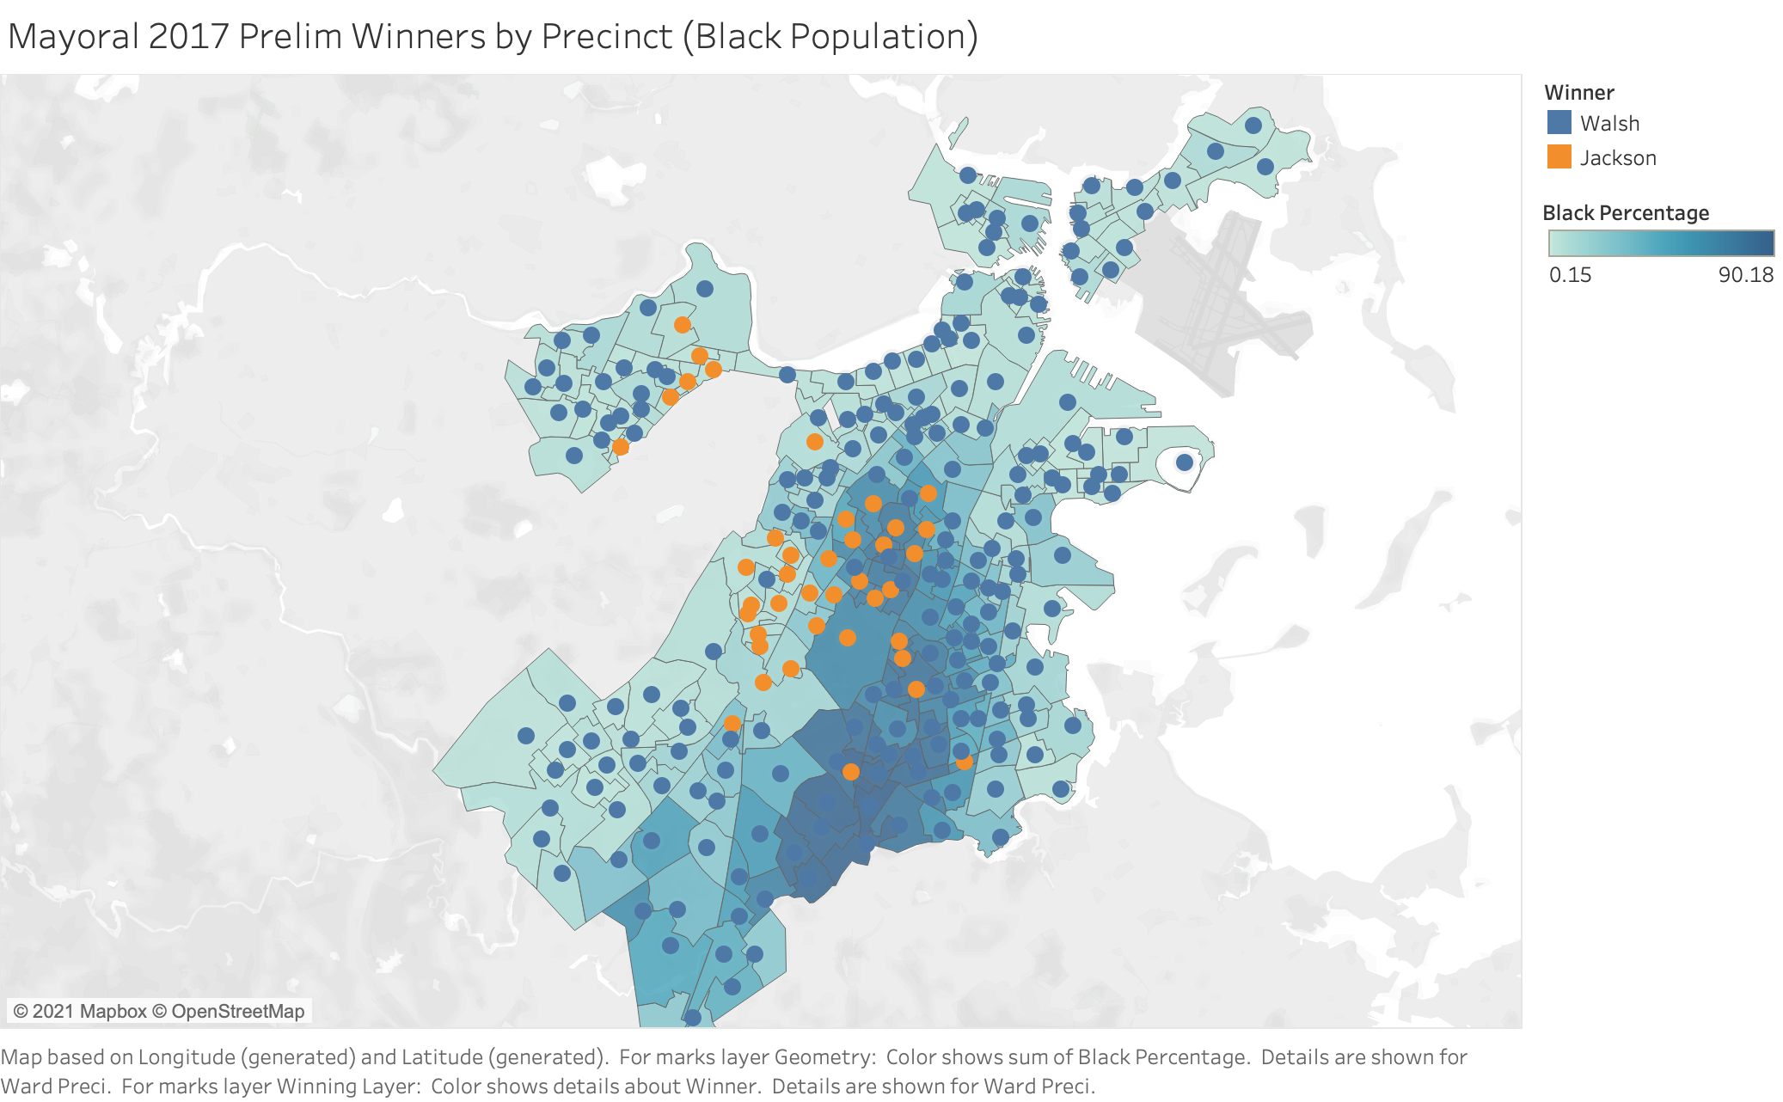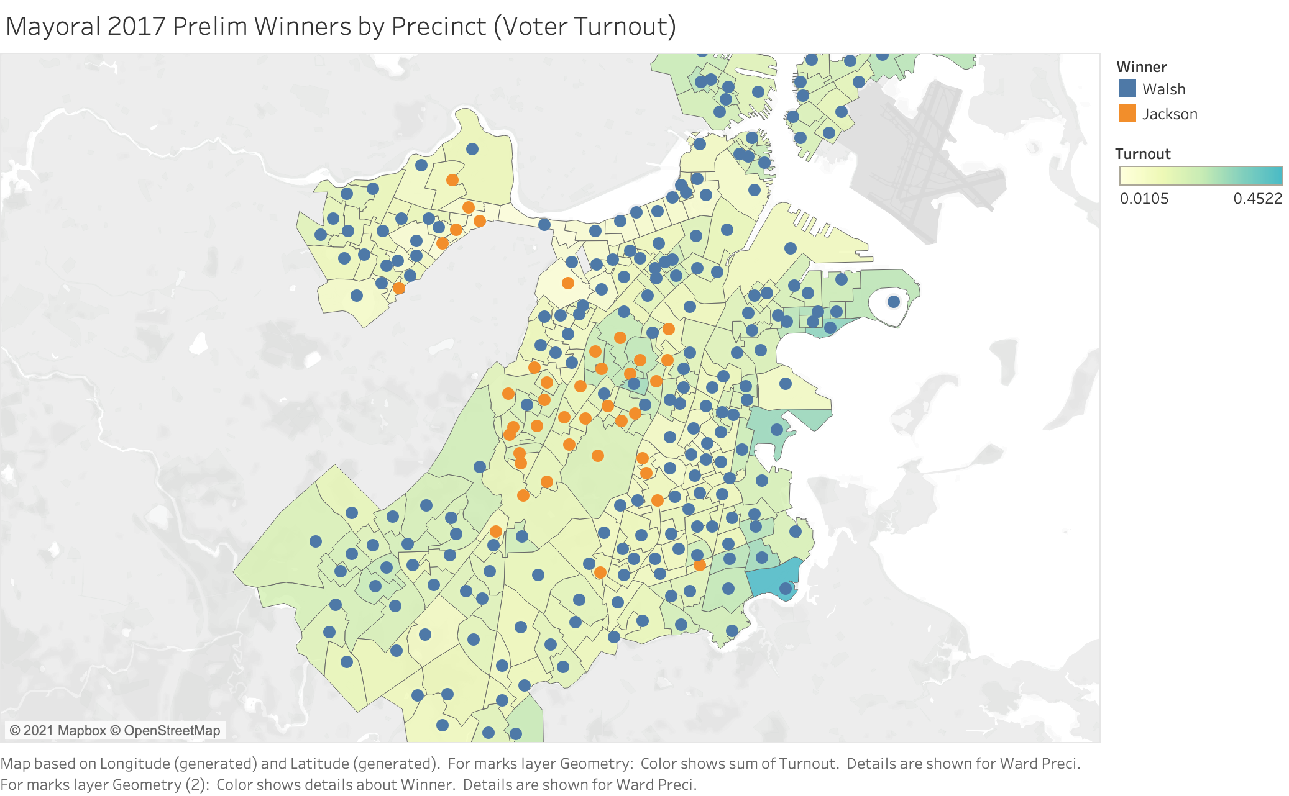

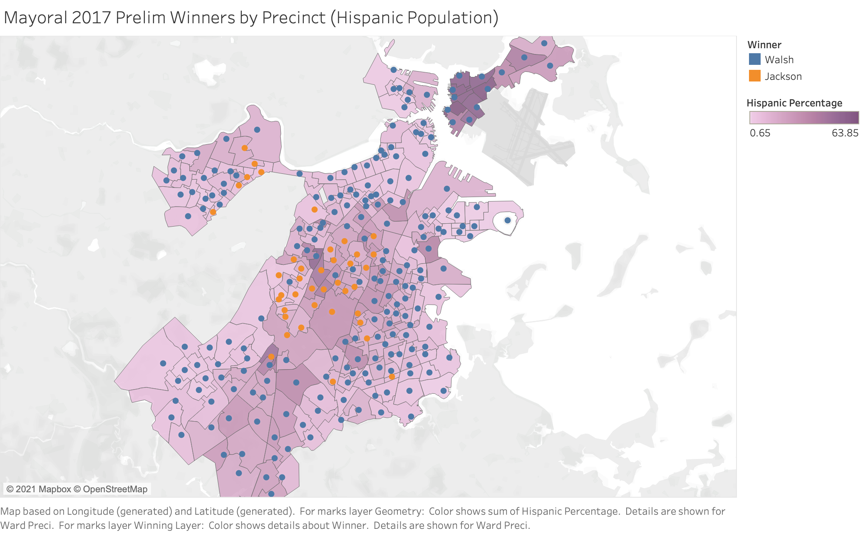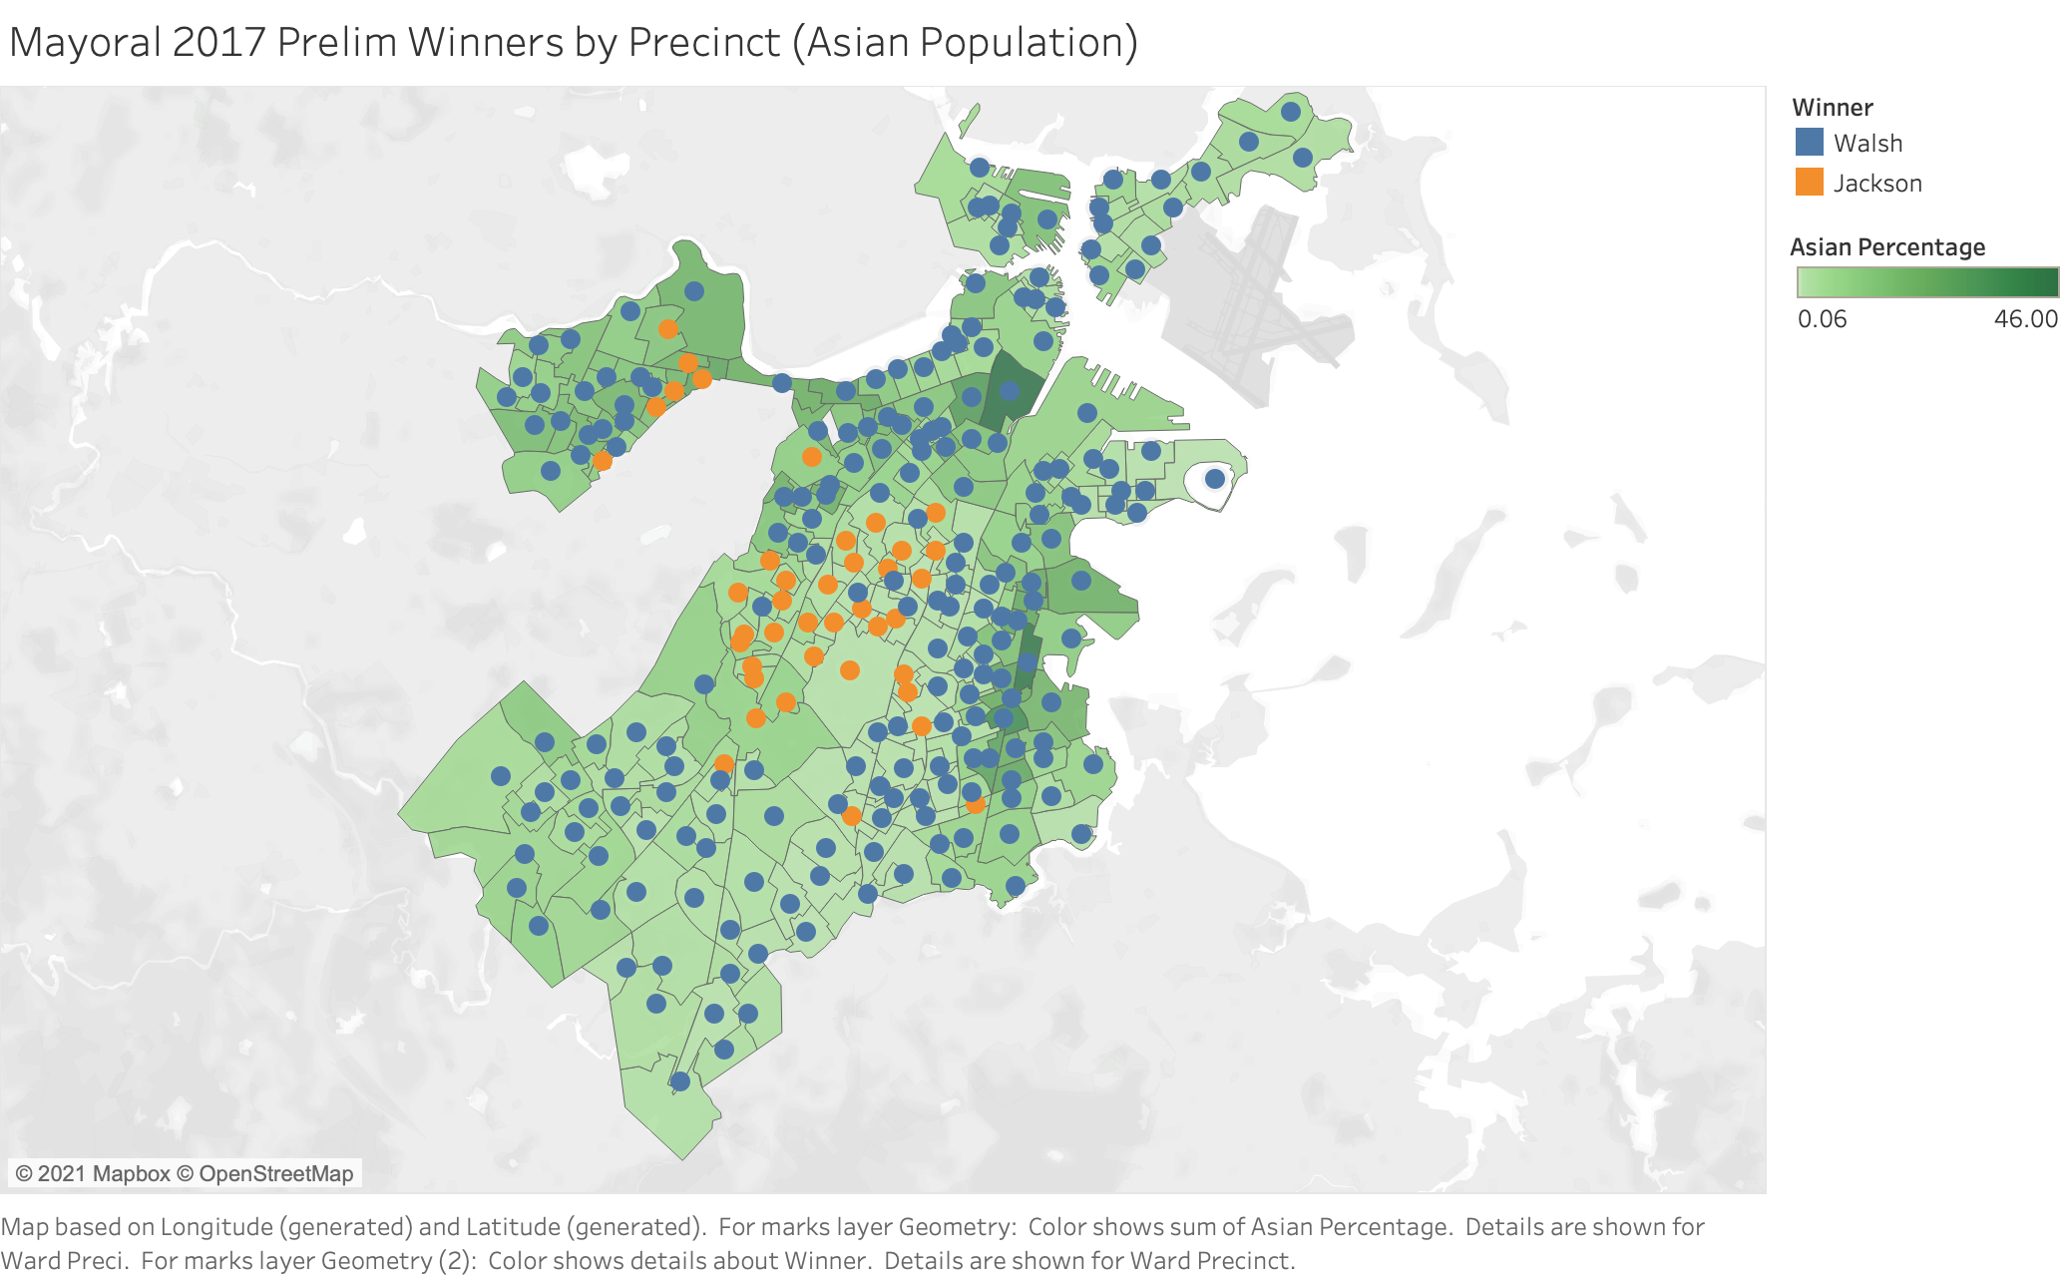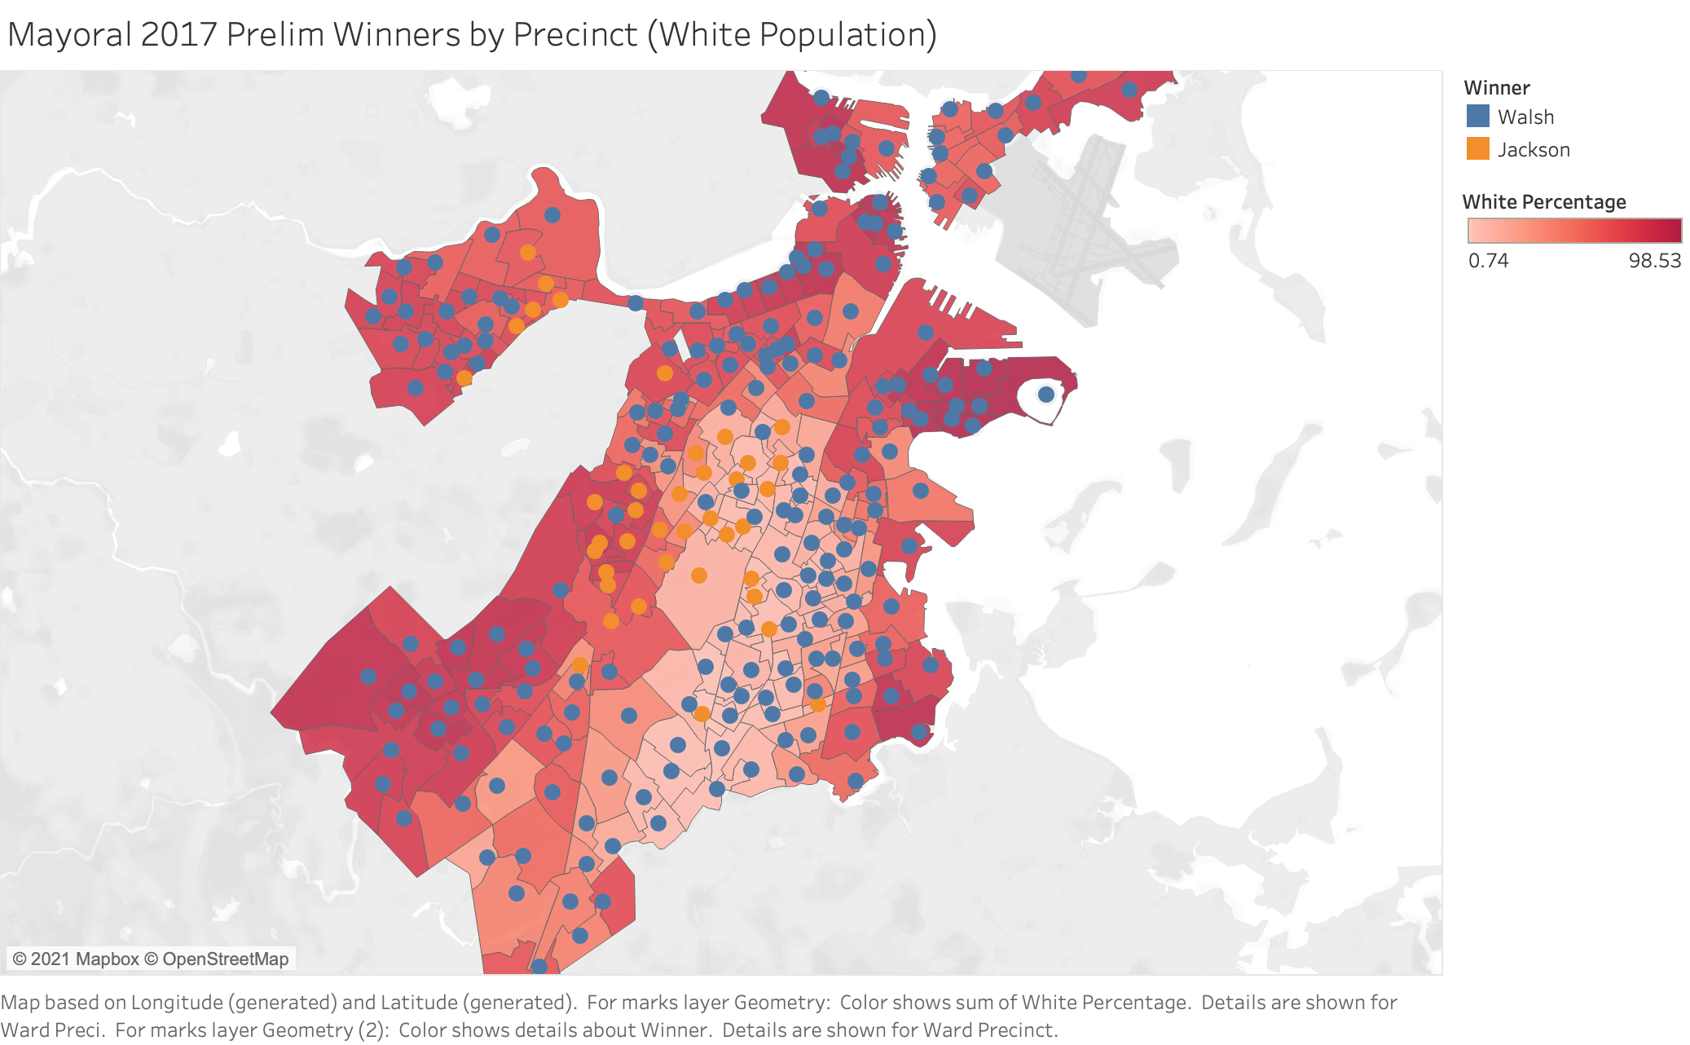

**General Race:**

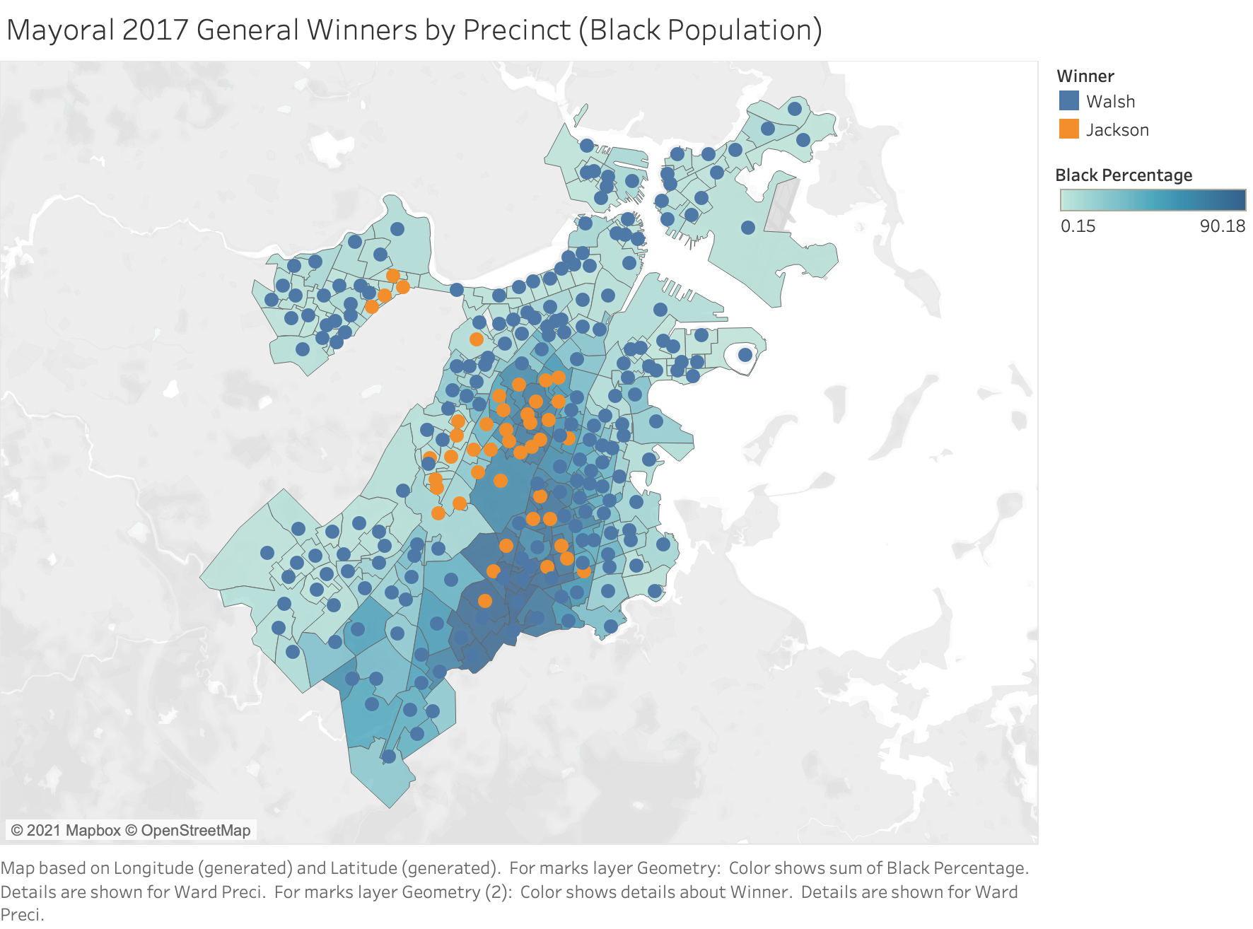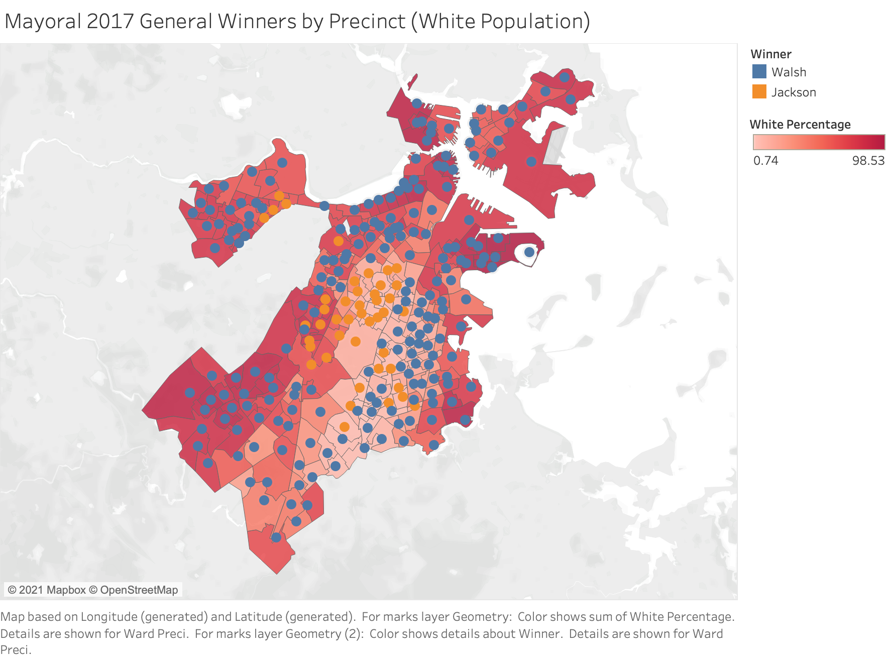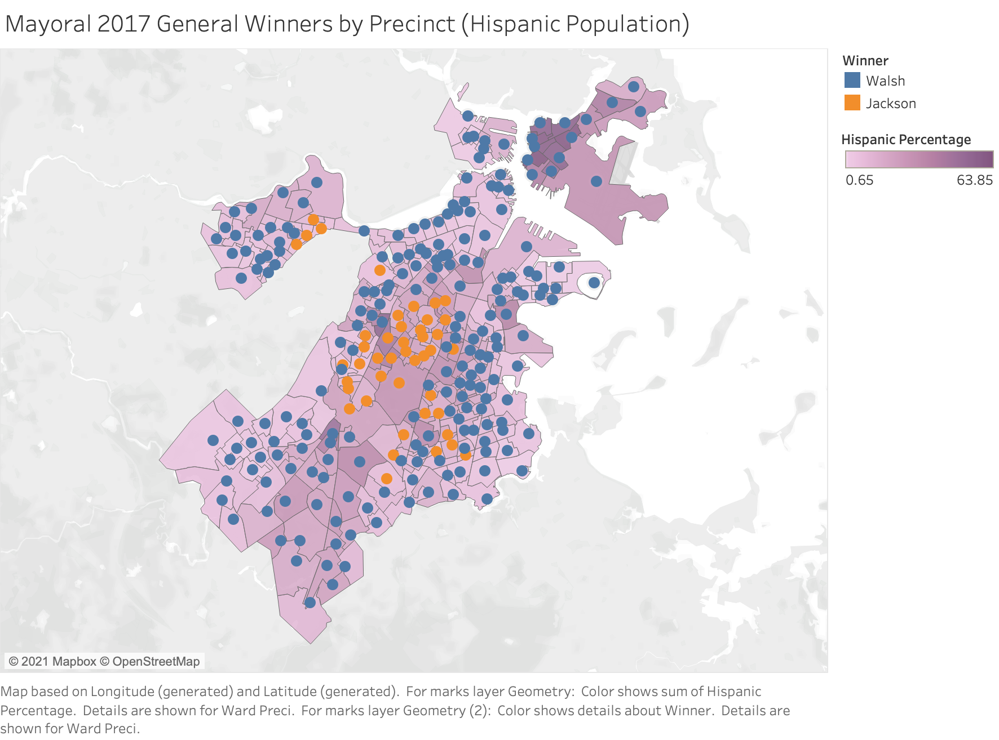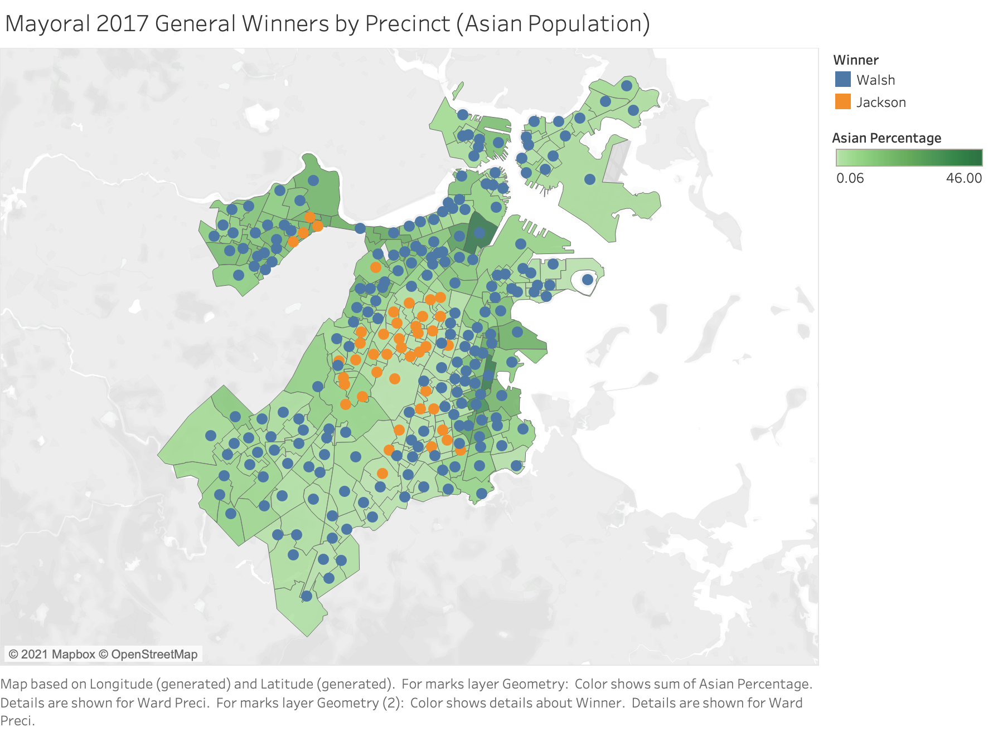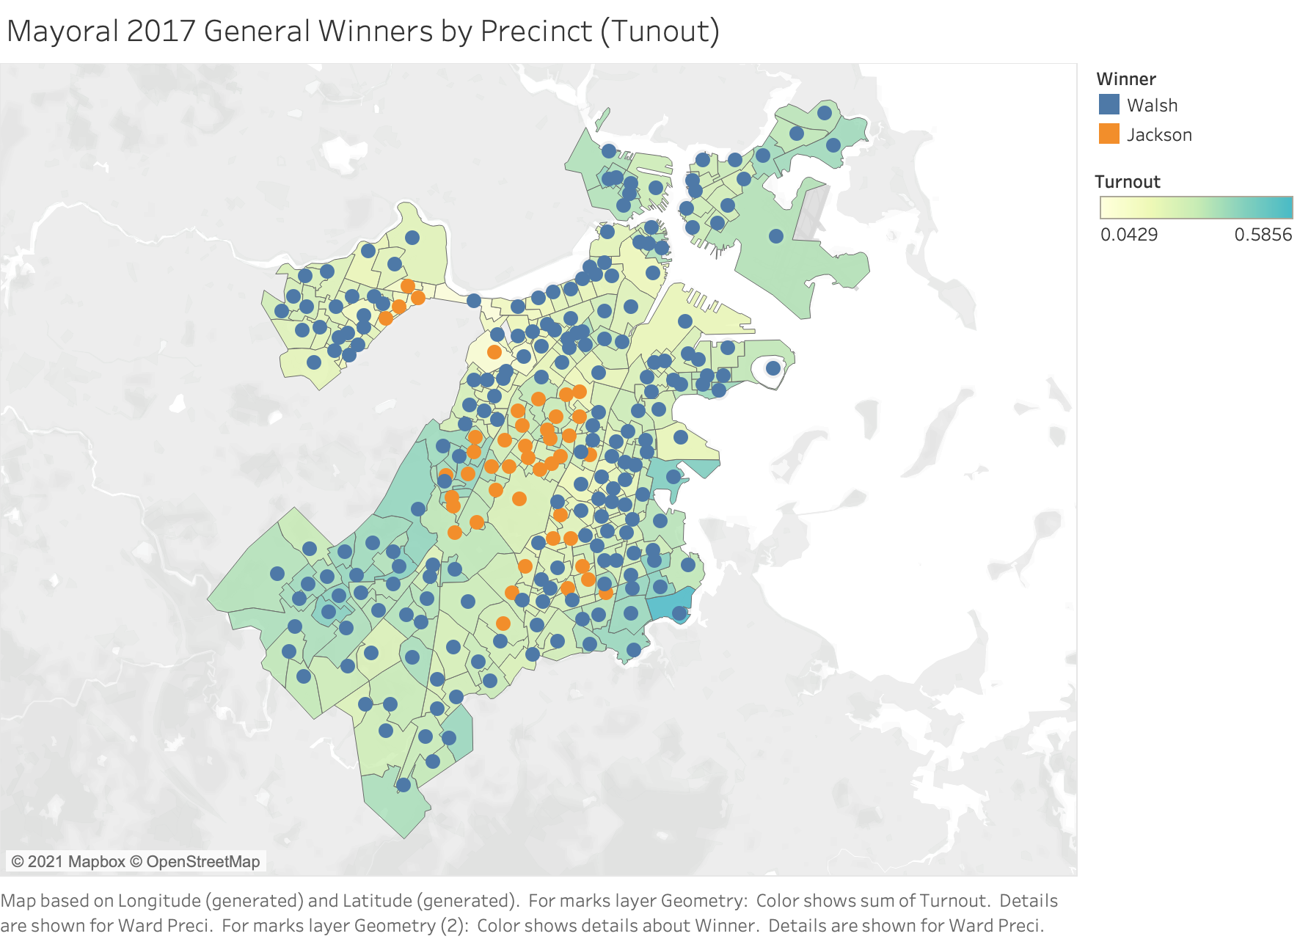

2019 City Council Analysis

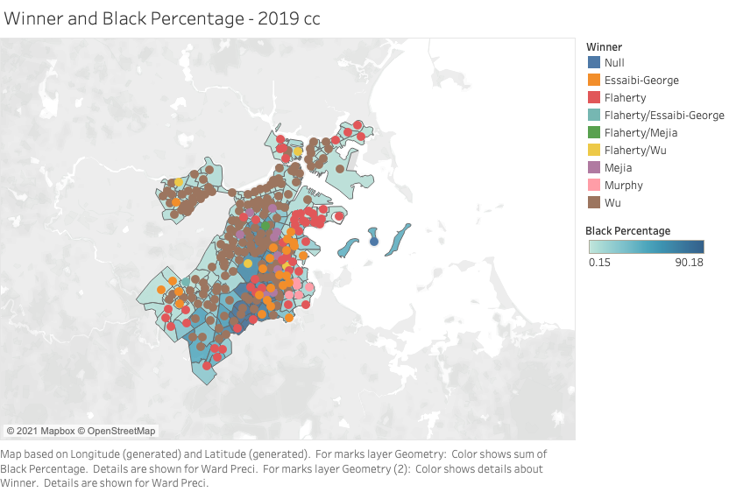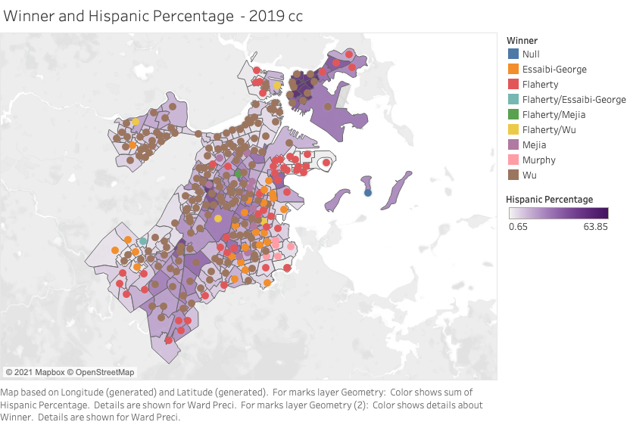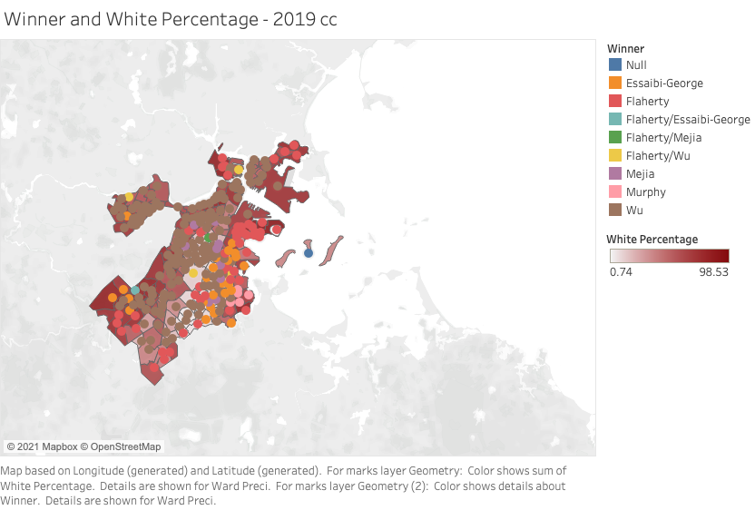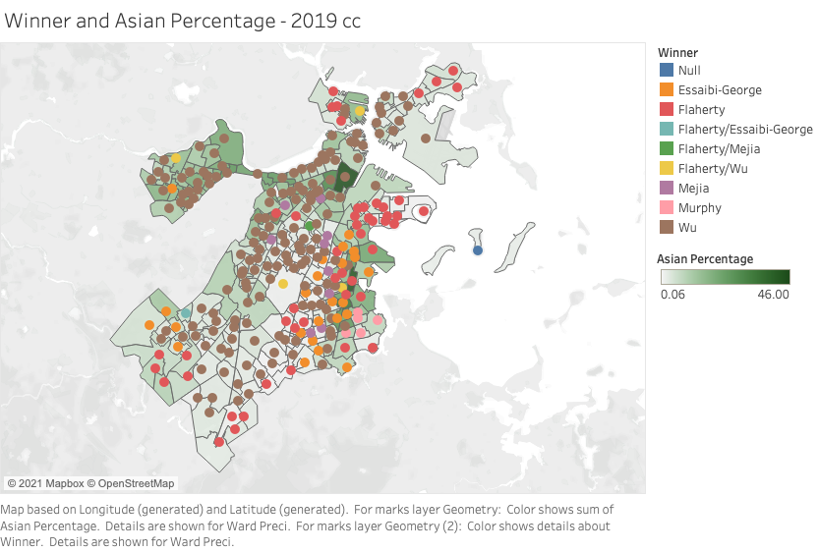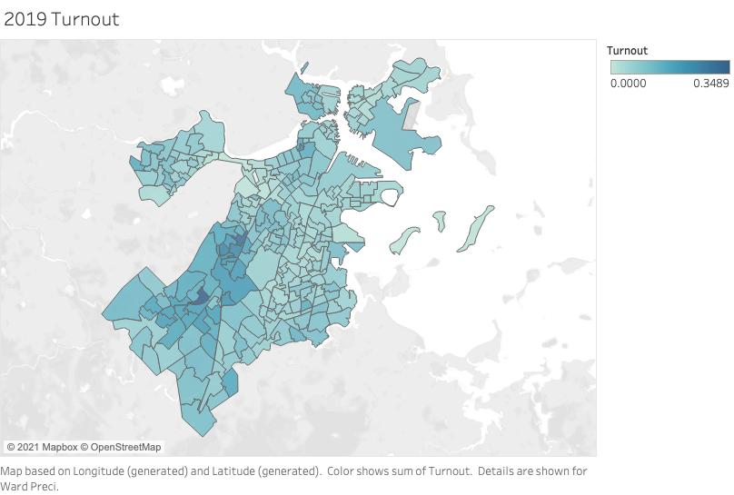

2017 City Council Analysis

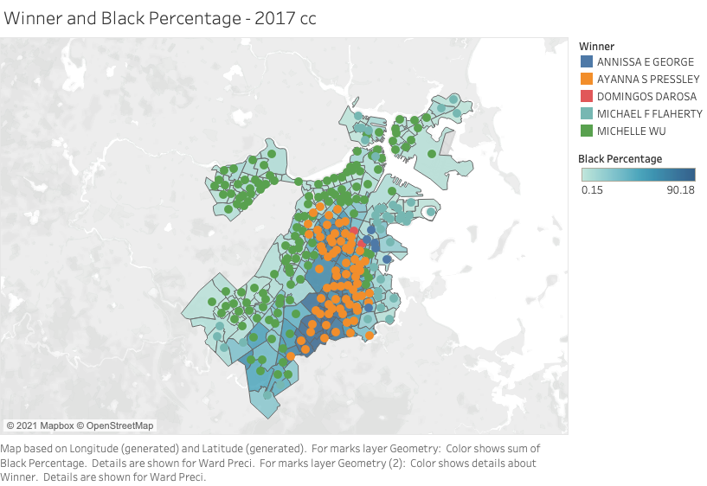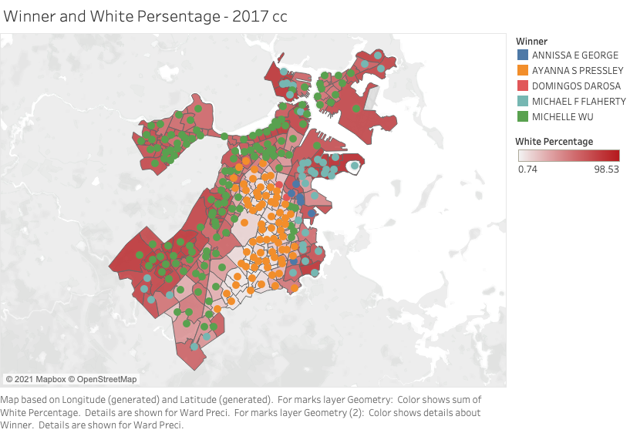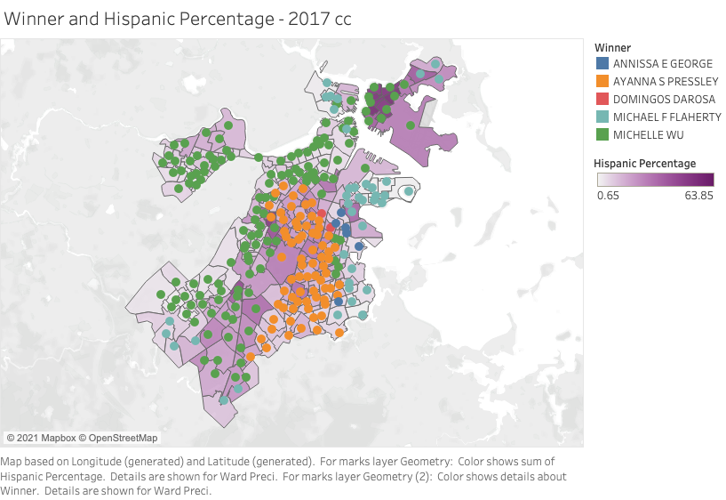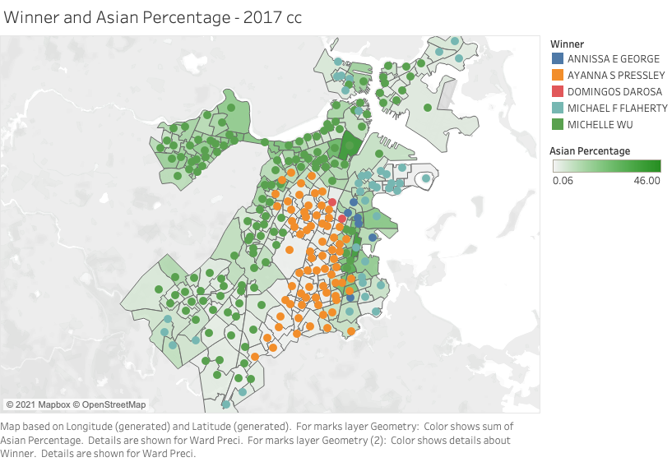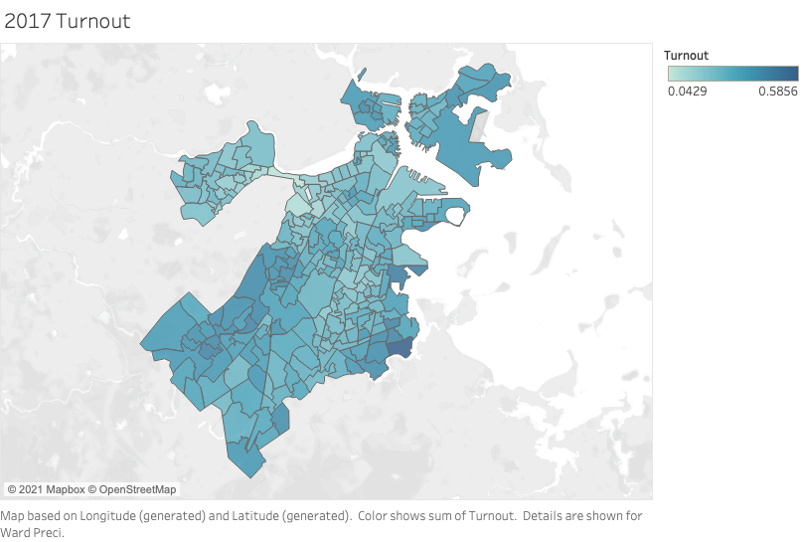

2015 City Council Analysis

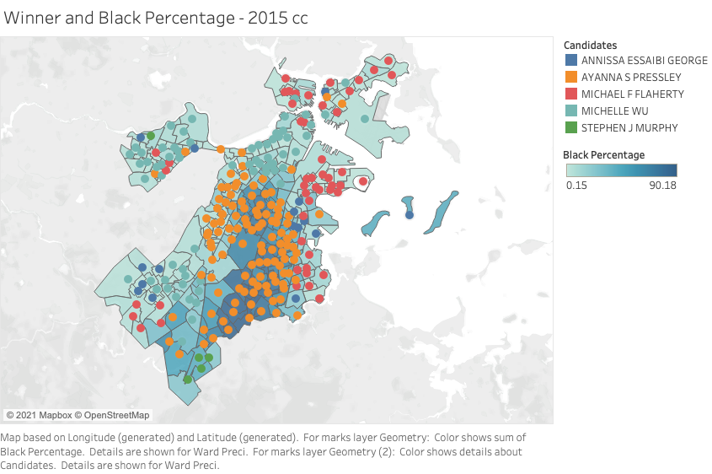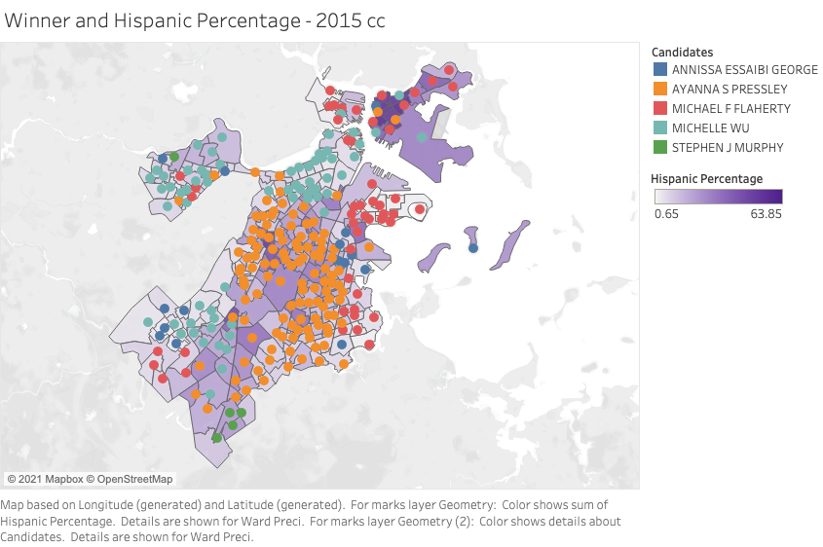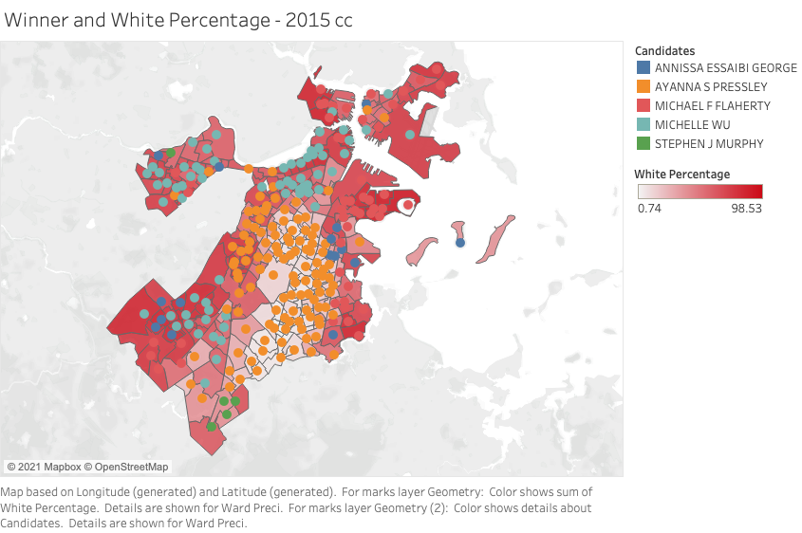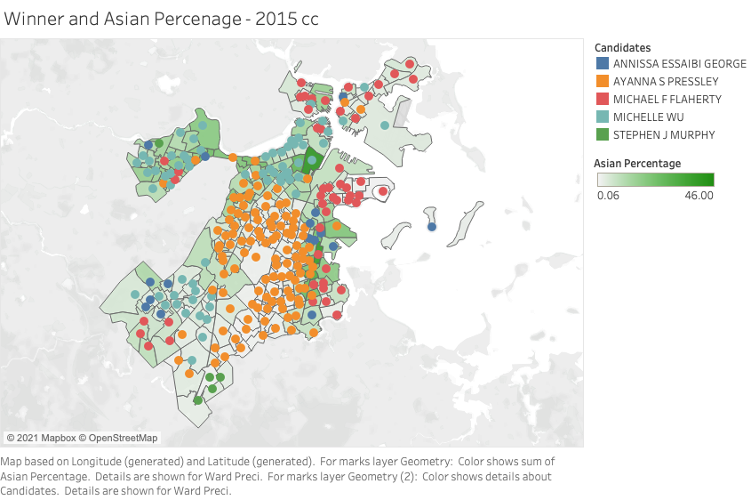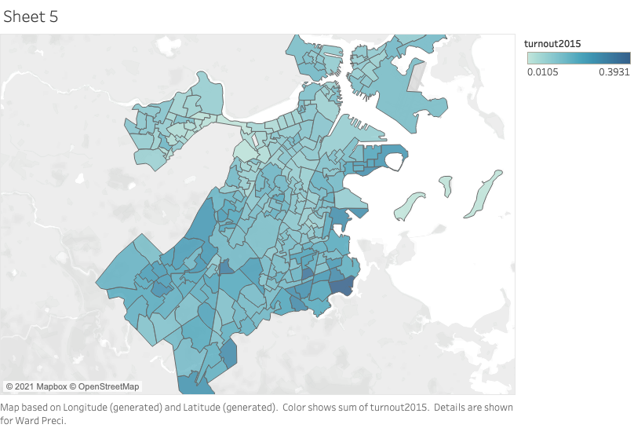

2013 City Council Analysis

Black Percentage & Candidates

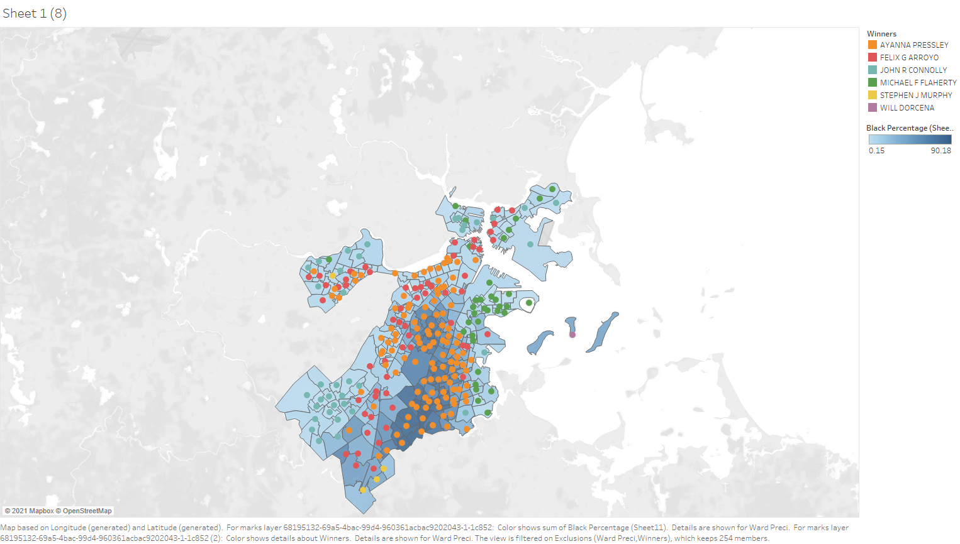

Hispanic Percentage & Candidates

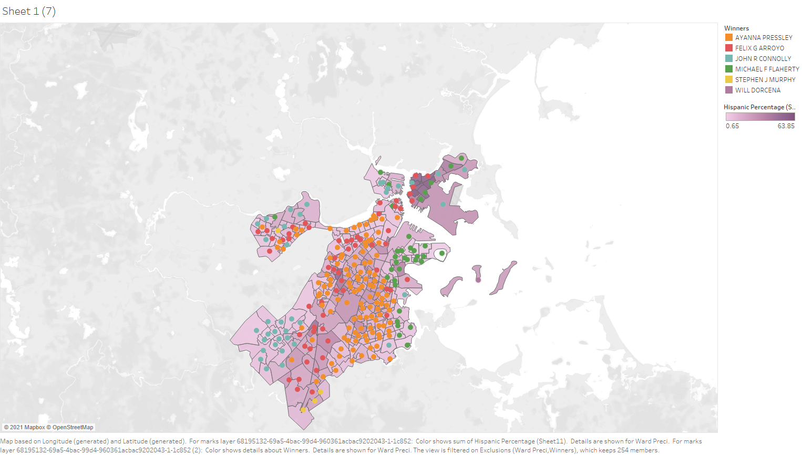

White Percentage & Candidates

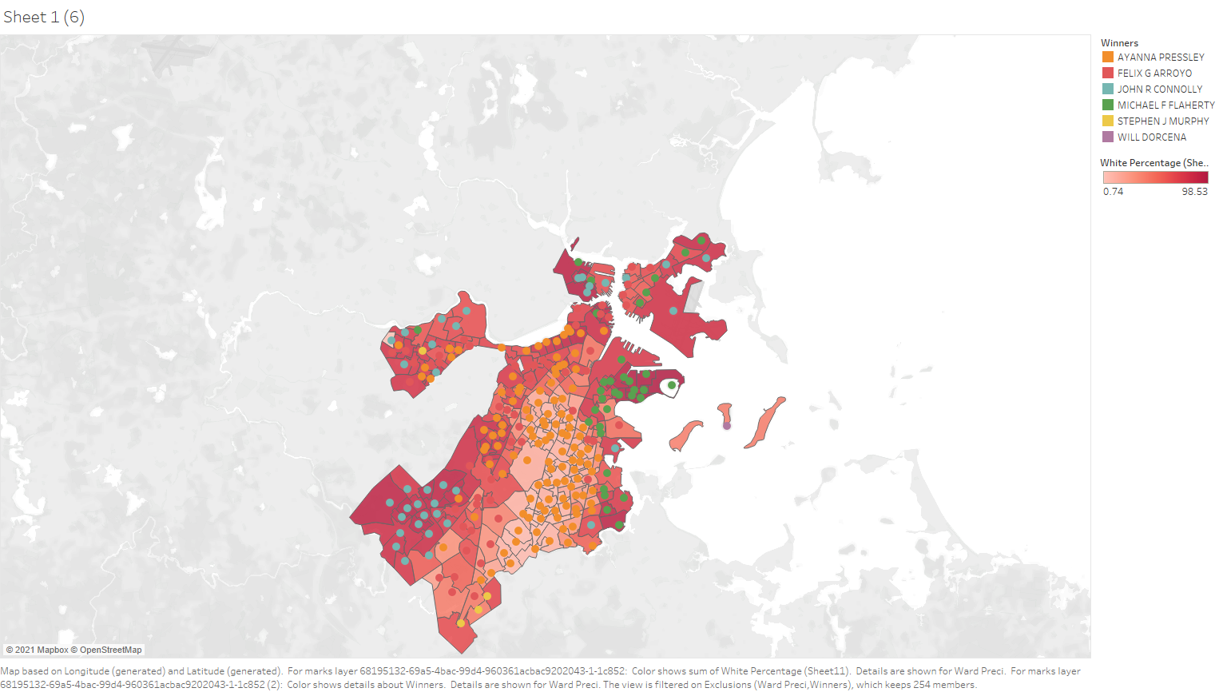

Asian Percentage & Candidates

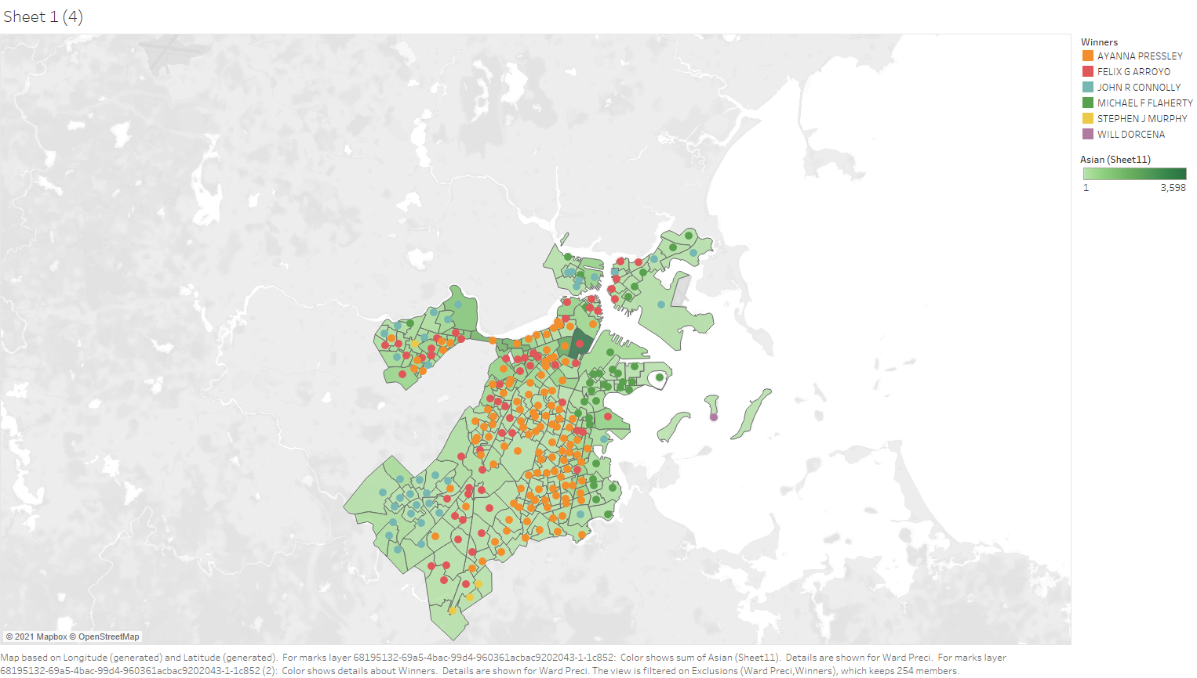

2011 City Council Analysis

Black Percentage & Candidates

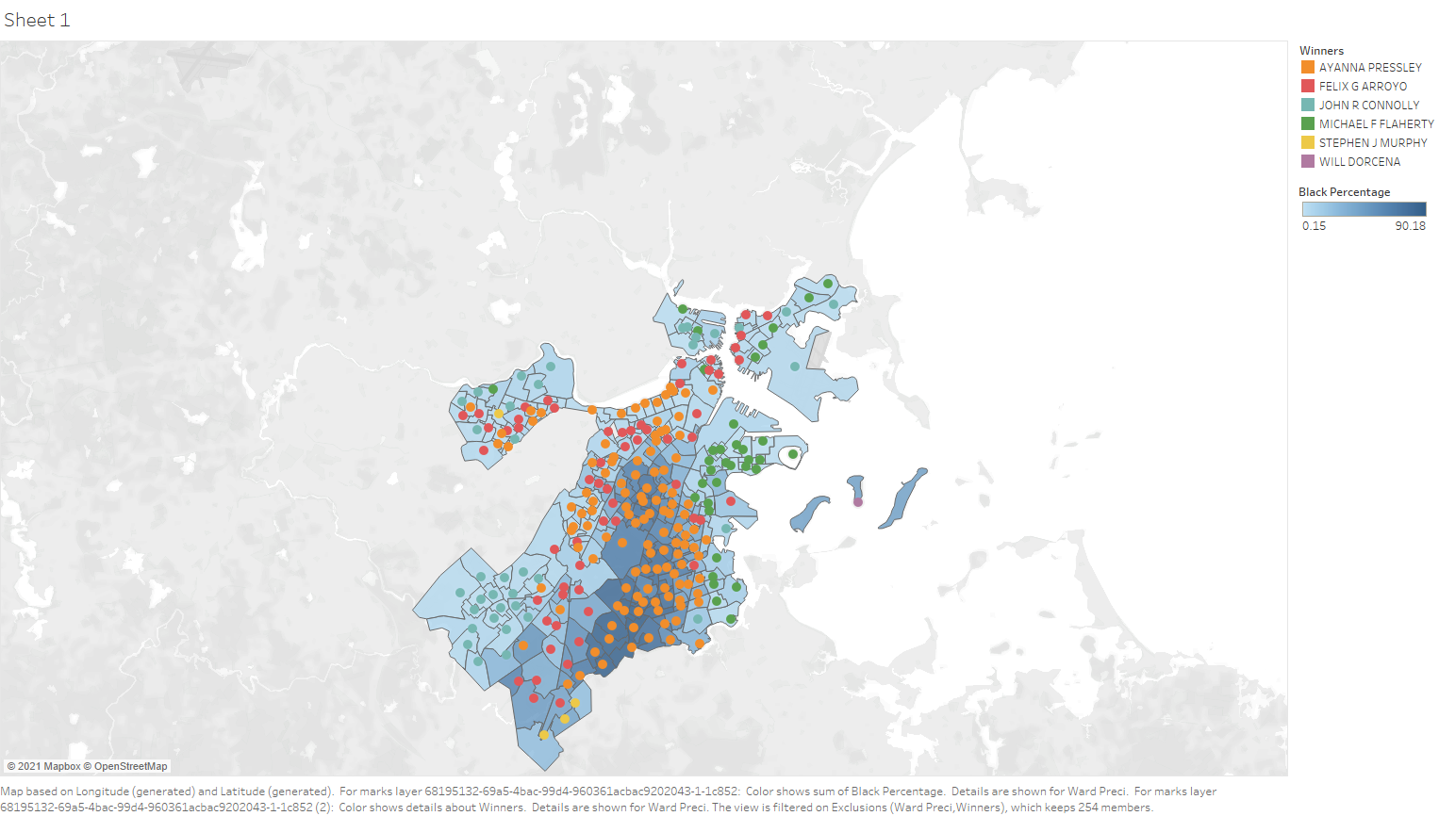

Hispanic Percentage & Candidates

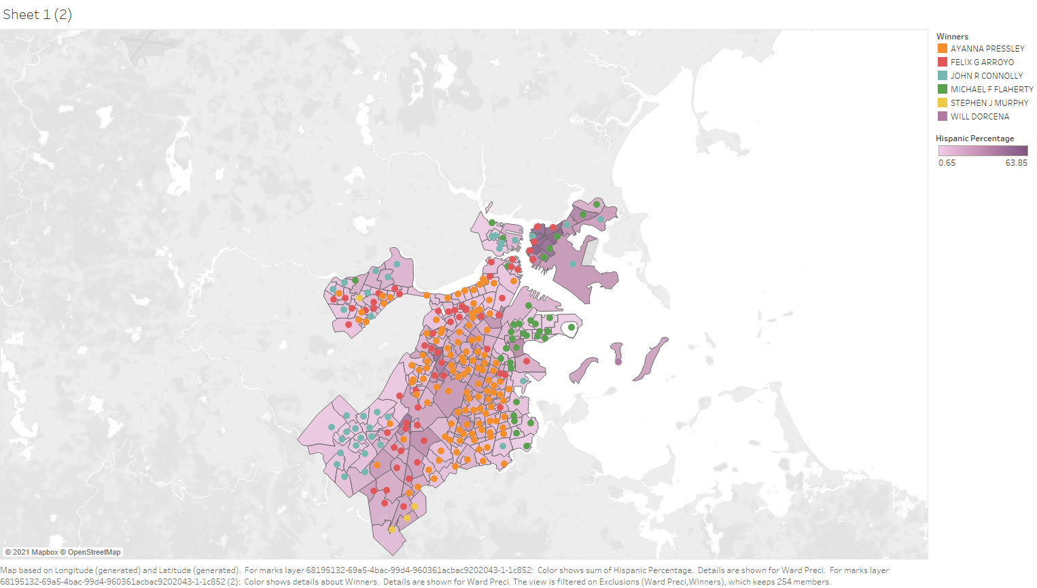

White Percentage & Candidates

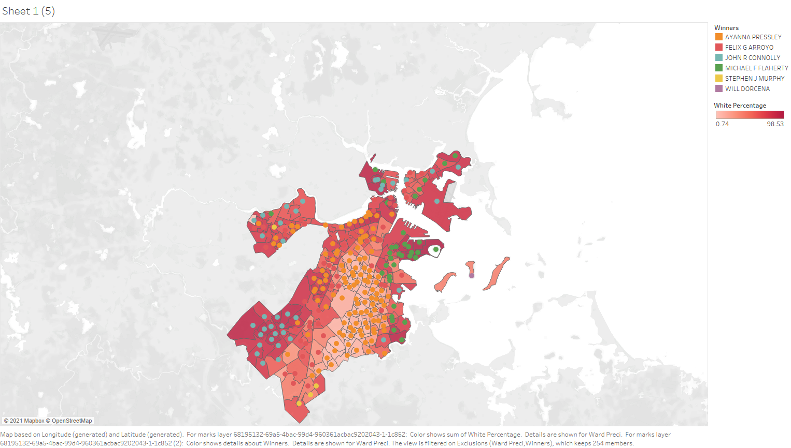

Asian Percentage & Candidates

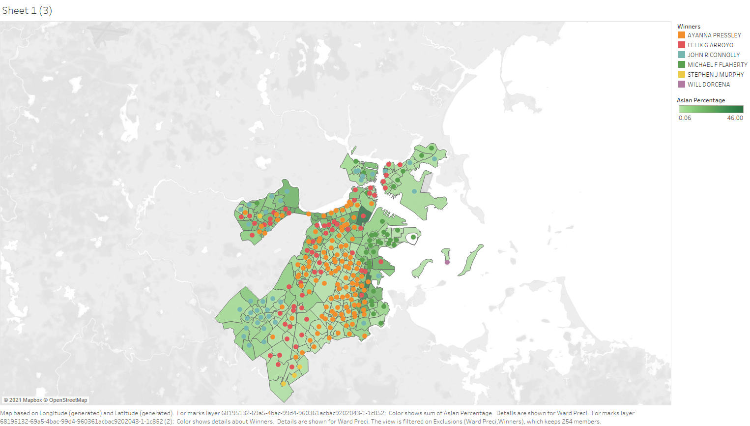

2020 US Senate Democratic Primary

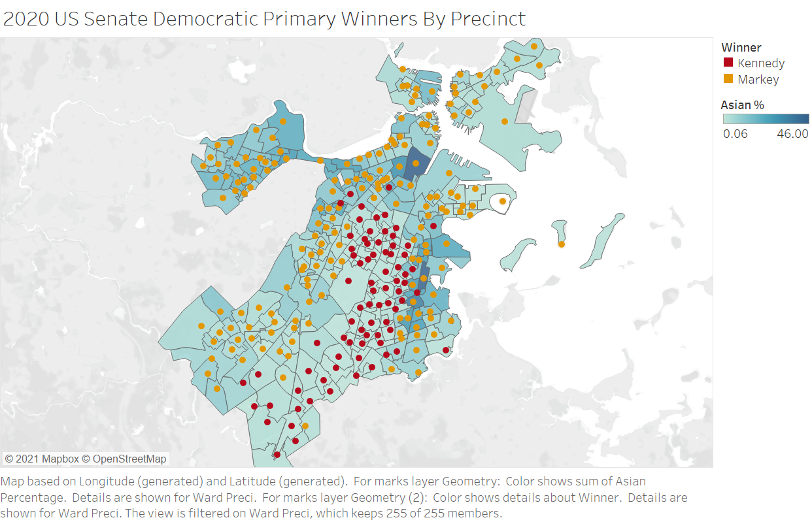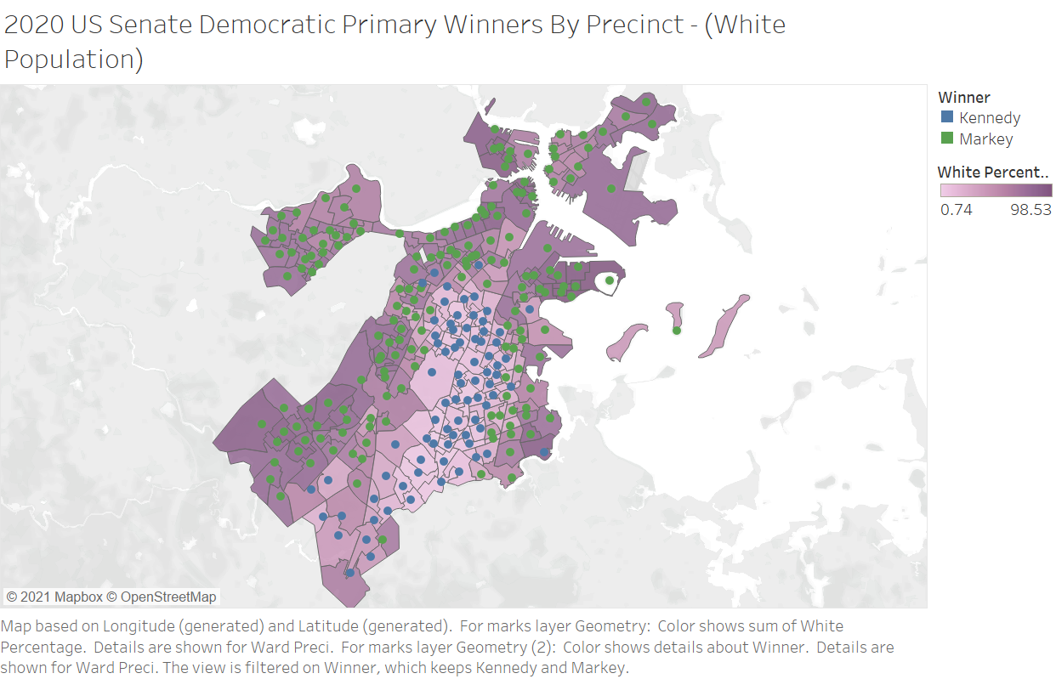

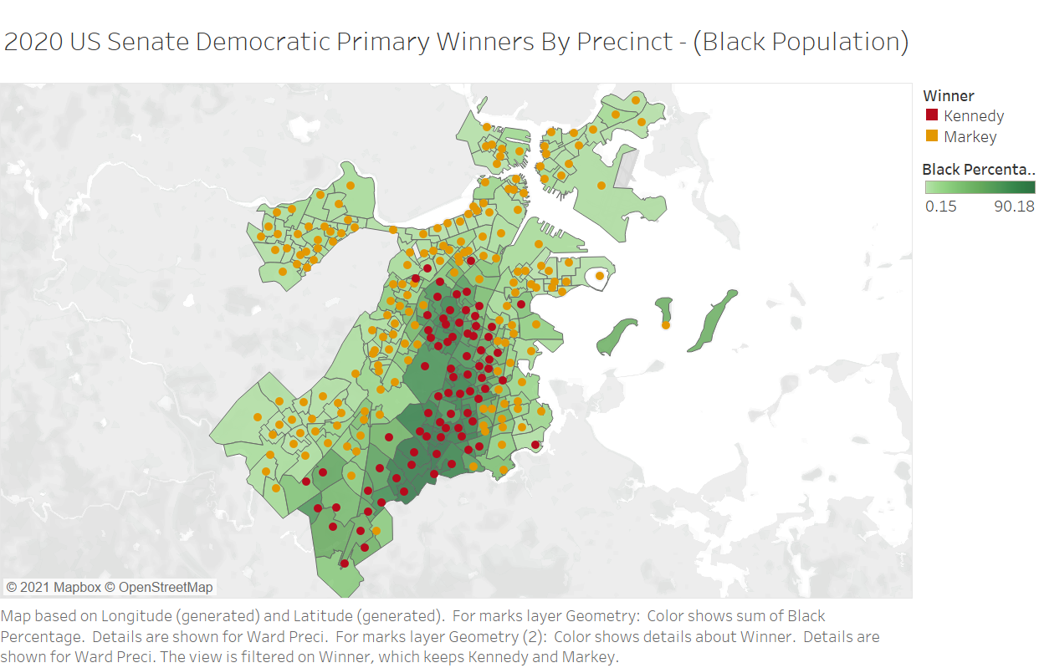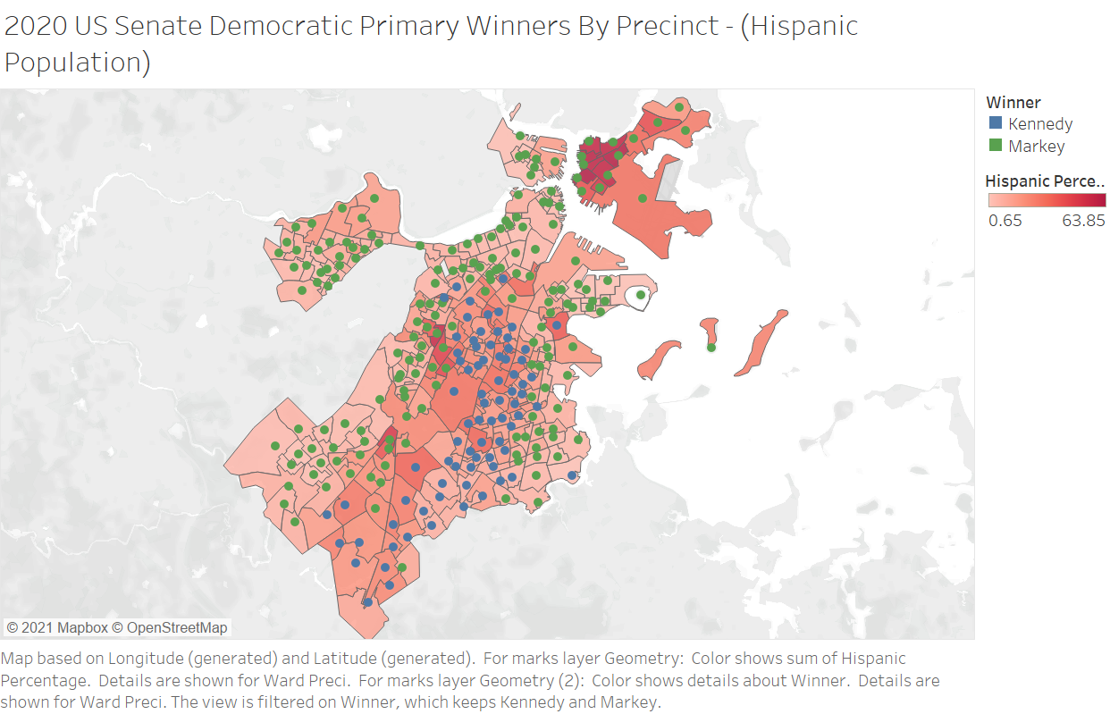

2018 US House Democratic Primary

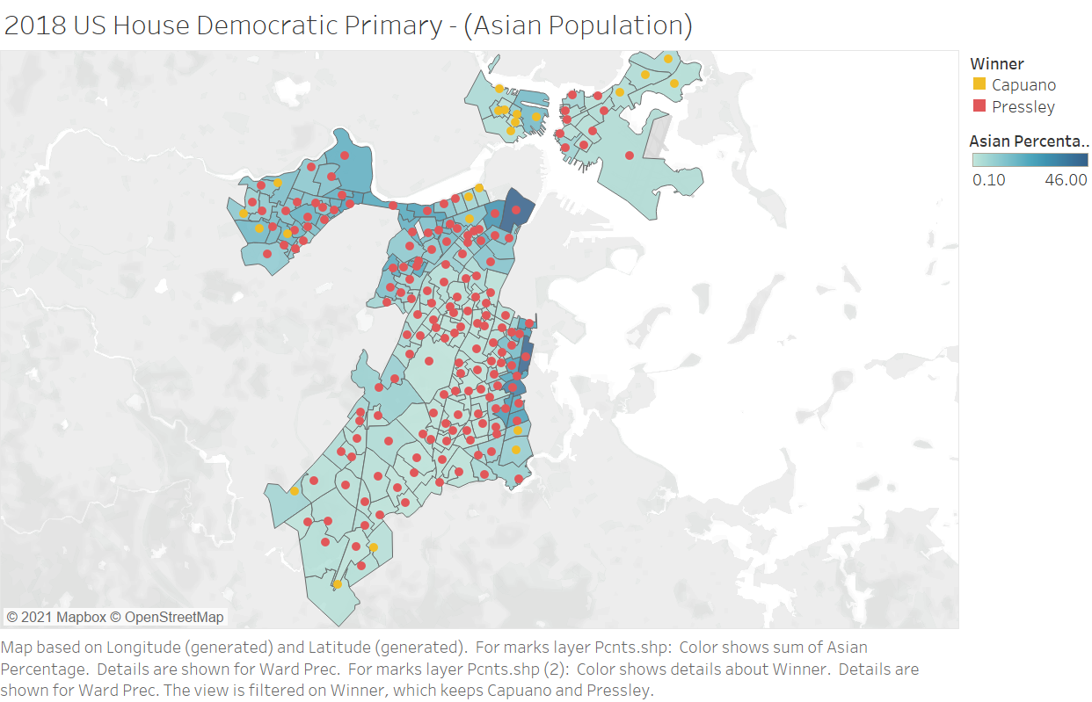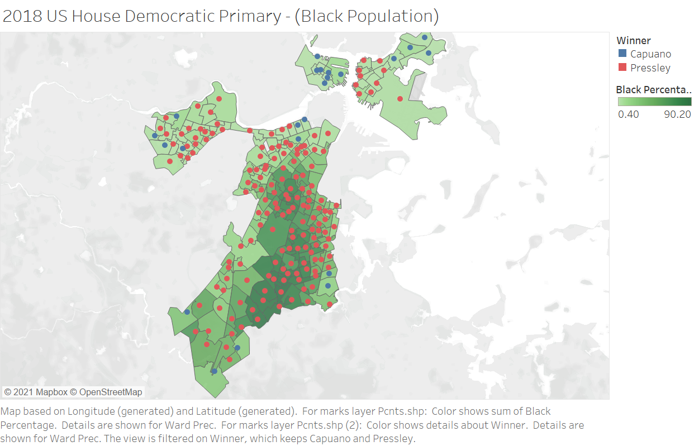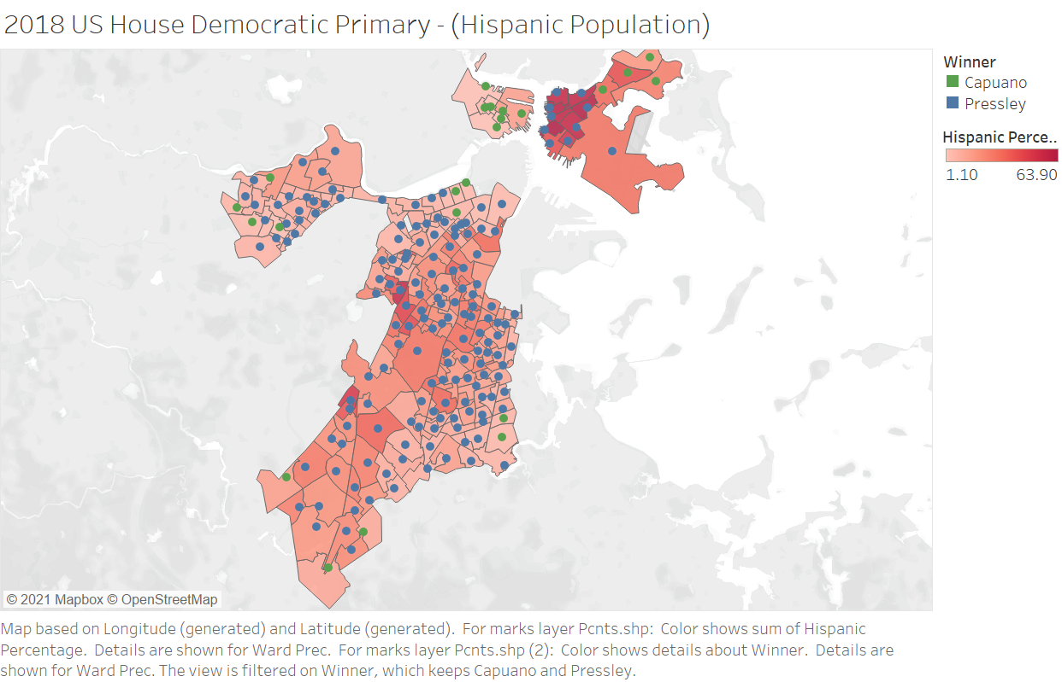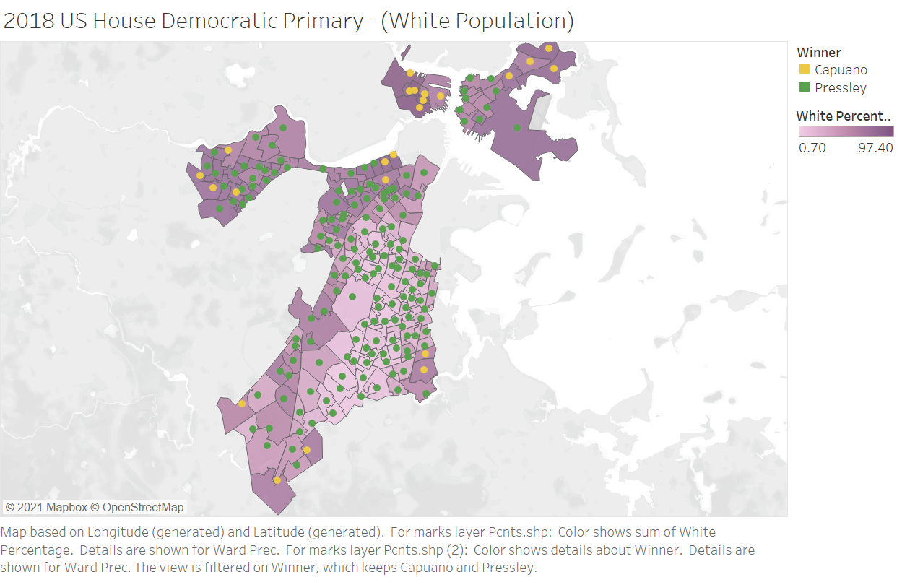

DA Race 2018

